Raiden. Power System Transient Stability Simulation Software Prototype

Eugene Mashalov
Joint Stock Company "Scientific and Technical Center of Unified Power System
Ekaterinburg, Russia
mashalov@niipt-ems.ru

Abstract—This paper discusses implementation details of the transient stability analysis prototype software "Raiden", based on the implicit integration scheme. The main advantages of an implicit integration scheme with combined treatment of differential and algebraic variables as well as an integration process with discrete event handling are considered. The results of test simulations and their comparison with existing software are presented.
Keywords—Transient Stability Analysis, Implicit Integration, Discontinuous DAE

Introduction
Stability simulation is one of the most complicated tasks of power system analysis. Besides methodological complexity, it requires intense computation with significant time consumption. Parallel implementation of simulation algorithms is difficult due to the sequential nature of the solution method, which is based on integration of the differential-algebraic system of equations (DAE). This type of problem is hardly separable into independent parts both in time and space. Even modern computer systems do not provide the opportunity for real-time simulation, unless model details are reduced. Transient stability is dominantly used in offline applications, such as facility development, and is rarely used for power system control on a time scale close to real-time.
However, some near-real-time implementations have been introduced in the last decade. One of the most successful is the stability monitoring system, used by the System Operator of Russia. The monitoring system evaluates the safe margins of network load over a period of 40–900 s with respect to steady-state and transient stability. These margins are used for automatic or manual system control. The duration of the evaluation cycle is mostly dependent on the duration of the transient stability simulation. The aim of reducing the computation time of simulation led to the development of the software prototype "Raiden" based on the implicit integration scheme, instead of the former implementation "RUSTab" based on explicit methods. The new algorithm consists of three components of integration: the method, the scheme, and the process.

Transient stability simulation algorithm
Time spent on transient simulation is proportional to the number of numerical integration steps of the system
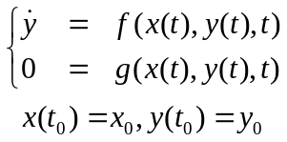 (1)
were g and f are continuous vector functions and y₀, x₀ are initial conditions. The time of initialization and computation of the initial conditions of simulation is much smaller than the time of (1) solution. The latter depends on the integration method properties and the system dimension N_{e}. In general, simulation time T_{hn}=O(N_{e}³), because the integration step requires the solution of a system of nonlinear algebraic equations in some form or another. The size of the integration step h_{n} is determined by the properties of the DAE. The crucial property of (1) with respect to h_{n} is the stiffness of the DAE [1].

The integration method
In most cases, the transient stability problem (1) is considered stiff, which encourages using implicit integration methods for its solution. The integration method is a vector function F(x,y) which maps values from the previous time step y_{n-1} to current values y_{n}. Of course, the current step values of the algebraic variables x_{n}←x_{n-1} are also required, but there are several approaches to obtaining them. Some implementations use separate solution of differential and algebraic equations, while others rely on simultaneous treatment. The simplest form of the implicit method for differential variables is:
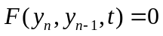 (2)
The solution of (2) involves the solution of the nonlinear system of equations. Integration step control bounds solution to:
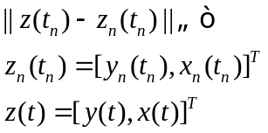 (3)
where: z_{n}(t_{n}) is the approximated solution, z(t) is the exact solution and ϵ is the error tolerance;
The integration step control varies h_{n}=t_{n} – t_{n-1} according to (3). For transient phases with rapid changes, the step is reduced. When the transient decays, the step can be increased, which significantly reduces the number of steps required to solve (1).
The implicit method implementation is much more complicated than the explicit one, as it requires a solution of the non-linear system of equations. That was the main reason for the former implementation of transient stability software, which algorithms were developed in the mid-1980s relying on explicit methods. In most cases, the solution is provided by the Newton’s method. Power system equipment models should be implemented with respect to this requirement and provide the ability to construct blocks of partial derivatives of the Jacobi matrix. Another problem that arises from nonlinearities is the possibility of multiple solutions at the time instants of discontinuities. However, the problems where (1) has discontinuous f and g are well known and there are various approaches developed. Some use rigorous discontinuity modeling [2], while others use integration restart techniques [3].

The integration scheme
The DAE (1) solution implies discretization into a pure algebraic system of equations using a chosen integration method. An iterative solution method is used since the resulting system is nonlinear. The simplest method is fixed point iteration. This method is applicable, but, in many cases, does not provide convergence due to its limitations. The application of the Newton’s method requires Jacobi matrix formation, which greatly increases the equipment models development complexity, but this problem can be solved by the automatic implementation systems [4]. On the other hand, Newton’s method makes it possible to reliably obtain a solution, has good convergence, and, moreover, can be used not only to solve (1) but also to determine the initial conditions at t₀ and at the time instants of discrete events t_{d}. The weak side of Newton’s method is its sensitivity to the quality of the initial guess. This problem is largely solved by using the initial estimation from the previous integration step. An additional factor that improves the convergence of the Newton’s method can be the integration method scheme. A well-known integration approach is the predictor-corrector scheme. With values of the solution available from the previous step z_{n-1}, the scheme predicts the values of z_{n} using extrapolation. The resulting prediction is used as an initial guess for the solution of the equivalent to (1) system, in which the differential equations are discretized. During the solution, the prediction is corrected so that the values satisfy the given system of equations. This scheme is effectively implemented using multi-step integration methods, which imply saving the history of several completed steps to perform the next step. To solve DAE, this approach is implemented in Gear’s method [5]. This method involves the use of the BDF integration method, both for differential and algebraic equations, and provides a simultaneous solution of (1). Such an integration scheme is fully implicit and preserves integration method stability properties.
A variant of Gear’s method is implemented in the well-known software EUROSTAG [6]. Since the methods of the BDF type have the property of damping high-frequency oscillations with an increase in the integration step, Gear’s method exhibits "hyperstability", which can lead to erroneous treatment of unstable cases as stable. The proposed by the authors of EUROSTAG modification, which consists of applying Adams method to differential variables, eliminates this drawback since the 2nd order Adams method is A-stable. The use of the BDF for algebraic variables makes it possible to maintain a higher integration step compared to Adams method with the same overall stability properties of the integration scheme.
All linear multistep methods of order q, despite significant differences in their properties, can be expressed in the Nordsieck form [1]. The Nordsieck vector has a dimension of 1×q+1. Since the integration method must be A-stable, the order is constrained to (q ≤ 2) and the maximum dimension of the Nordsieck vector is limited to 1×3.
At the n-th integration step, Nordsieck vector components of differential and algebraic variables are:
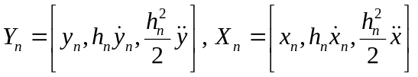 (4)
The Nordsieck vector is merely a form to express the Taylor’s expansions of y_{n} and x_{n} at t_{n}. If this vector for t_{n-1} is known, the prediction at t_{n} is:
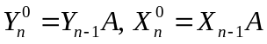 (5)
where:
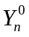 is the differential variables vector extrapolated to t_{n};
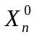 is the algebraic variables vector extrapolated to t_{n};
A is the lower triangular Pascal matrix q+1×q+1.
The corrected Nordsieck vector at t_{n} is:
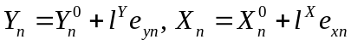 (6)
where l^{Y} is the row vector of integration method for differential variables, l^{X} is the row vector of integration method for algebraic variables and e_{yn}, e_{xn} are the error vectors between predicted and corrected values of state variables;
The vectors l^{Y} and l^{X} are normalized:
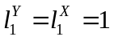 (7)
The corrector equations (6) can be written by components:
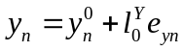 (8a)
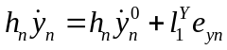 (8b)
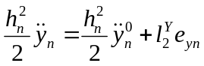 (8c)
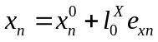 (8d)
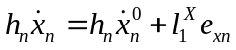 (8e)
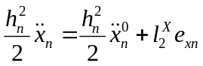 (8f)
From the equation (8b) combined with (1):
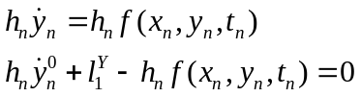 (9)
Using (7) define:
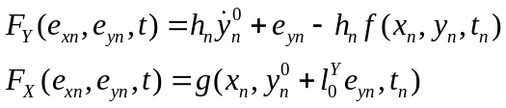 (10)
from which the following system can be obtained:
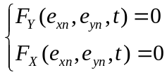 (11)
with Jacobi matrix (n step index is omitted for simplicity):
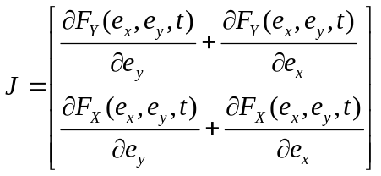 (12)
The combination of (10) and (12) gives:
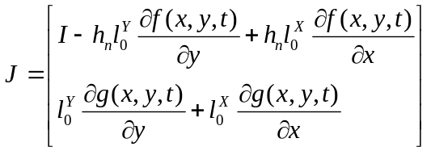 (13)
Note that the Jacobi matrix does not become singular with h_{n}→0, which allows it to be used to solve DAE for initial conditions y_{d}, x_{d} at instants of discontinuities t_{d}. In addition, step reduction does not cause numerical problems, which, for example, the integration scheme [7] is subjected to.
The system of equations (11) can be solved iteratively. Variables at iteration m are:
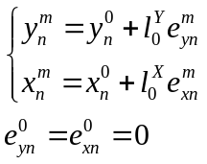 (14)
The iterative process of solving (11) with respect to e_{yn} and e_{xn} is arranged according to the recursive formula (n step index is omitted for simplicity):
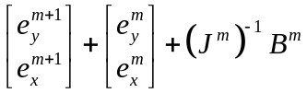 (15)
where:
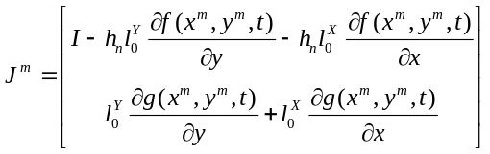 (16)
and:
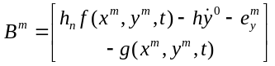 (17)
When the process (15) converges, the Nordsiek vectors X_{n} and Y_{n} at the t_{n} are updated once per step using (6).

Local truncation error control
The solution of (15) is the difference between predicted and corrected values of the state variables and it can be used for local truncation error estimation. The size of the next integration step and integration method order can be further determined using this estimation. Local truncation error d_{n} at the step n:
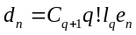 (18)
where C_{q+1} is the integration method constant. Since state variables may have very different magnitudes, it is common to use weighting vector for the error estimation:
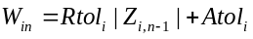 (19)
where Atol_{i} is the absolute tolerance of i-th state variable, Rtol_{i} is the relative tolerance of i-th state variable.
The condition (20) is used to accept step n:
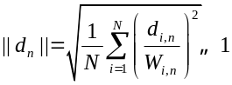 (20)
where N is the number of state variables. If (20) holds, the step and the order of the integration method are adjusted for the next step. The step is rejected and repeated with a smaller h otherwise.
The choice of the norm type for ||d|| estimation has a strong influence on the quality of the simulation. The default option is l²-norm, which is acceptable both for the quality of the solution and step size control. Since (1) is stiff, differential equations with small time constants tend to produce large differences between predicted and corrected values. The l²-norm averages these differences and allows the step size to be larger. However, this averaging property degrades the quality of simulation for models with large dimensions due to the "masking" of unacceptable errors in some state variables. These errors may have a crucial influence on the stability simulations and lead to erroneous estimation of unstable cases as stable. Using l∞-norm overcomes this problem but leads to an unacceptable time step decrease. A hybrid norm was proposed in [8], which combines properties of l²- and l∞-norms. In this paper, a similar approach based on the weighting of norms is applied.
The procedures for integration step and order change add extra computation costs and should not be used at every step. Step size and order control is based on the strategy described in [9], where these aspects are considered in relation to the pure differential system of equations. Since the problem being solved is differential-algebraic and stiff, additional measures for convergence control of the corrector and excessive step change suppression are implemented on the basis of [7].

Adams integration method ringing suppression
The implicit 2nd order Adams method, also known as the trapezoidal rule, has the property of "ringing" with the increase of the integration step. Ringing appears as oscillations of state variables at transient decay phases where the integration step is relatively large. Ringing does not affect the quality of simulations considerably but prevents the growth of the integration step, despite the fact that the physical process tends to a steady state.
The 2nd order Adams method (21) applied to the model equation 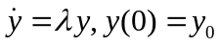 gives expression (22).
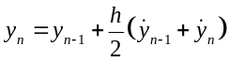 (21)
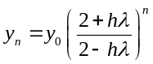 (22)
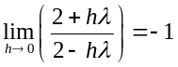 (23)
When the integration step increases significantly, the sign of the state variable changes at each integration step due to (23). To suppress ringing, it is necessary to eliminate the influence of the property (23) on the solution. Good results for the chosen integration scheme were obtained with the approach proposed in [10]. The idea is to interrupt (23), by replacing 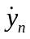 with the value of 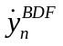, computed according to (24) after the solution of (21)
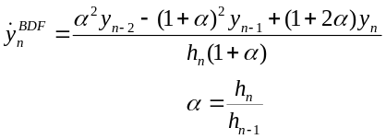 (24)
At the step n+1 the expression (21) would use instead of the value computed at the step n.
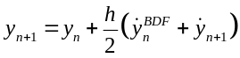 (25)
Since replacement 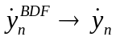 changes integration method stability properties, it is applied only when ringing is detected. The extra conditions to apply this artificial damping are h_{n} > 0.1 s and a cool-down period of several steps before the next damping. The effect of the ringing suppression is shown in Fig. 1 and Fig. 2.
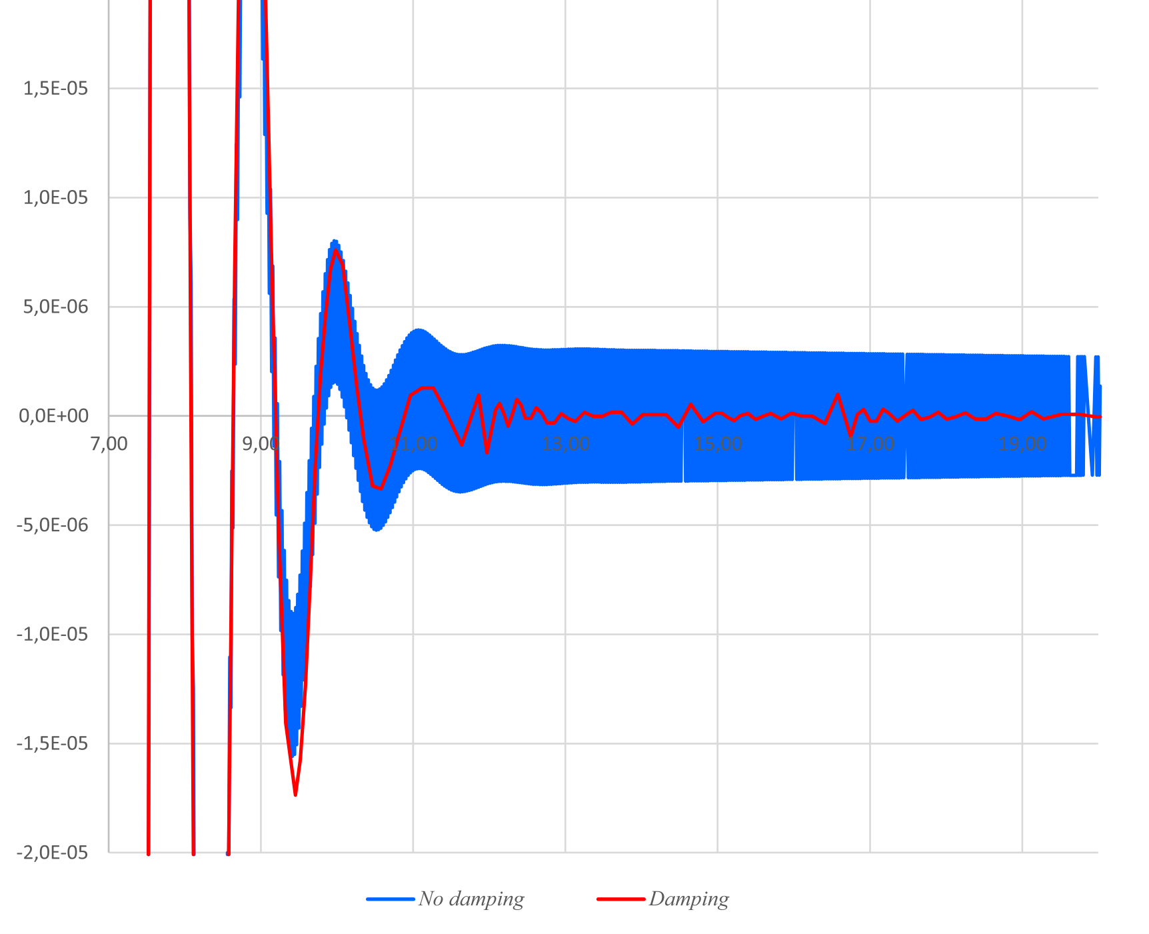
Fig. 1. The ringing suppression effect of the 2nd order Adams method on state variable evolutions
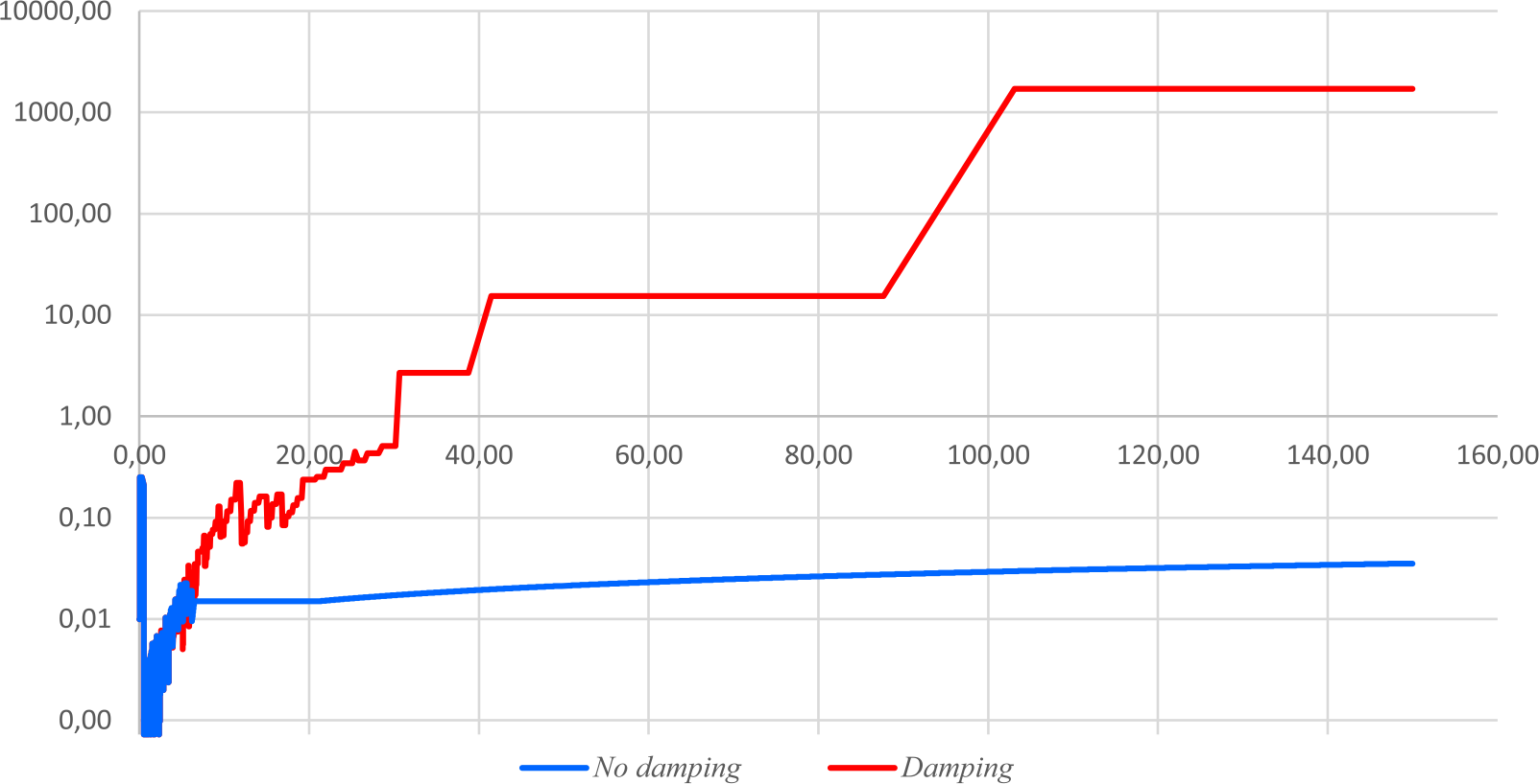
Fig. 2. The ringing suppression effect of the 2nd order Adams method on integration step size evolutions (log scale)

The integration process
The integration method and scheme considered above assume that (1) is continuous. When simulating practical transients, this condition is not met since some of the f and g or their derivatives are not continuous due to constraints or the are just discrete. In addition, to simulate discrete events, some of the equations of the system have to be modified. In some cases, the dimension of the system also changes. Problems in which system (1) is not continuous are the particular problem class of DSAR – Differential Switched Algebraic and State Reset equations [11]. An obvious approach for solving such problems is integrating a sequence of continuous DAEs.
The problem of DSAR treatment consists of the arrangement of a transition from one continuous DAE to the next one with consistent initial conditions at a time instant defined. The last problem is not trivial, since the nonlinearity and the presence of discrete functions make multiple solutions possible. Using the additional information available in the history of solution and specified in the form of model rules [4], the ambiguity can be resolved by a formal choice of the most plausible combination of state variables.
Thus, a full-fledged algorithm for transient stability simulation should implement the integration process, which governs the integration scheme and solves the following problems:
- Discrete events management.
- Discontinuities handling.
- Calculation of initial conditions and restart of integration.
- State events time instant’s location.
The discrete event is a command to modify (1) at an arbitrary time instant t_{d}. Command execution requires at least a restart of the integration scheme. In general, some modifications of (1) structure are also needed. The new consistent initial conditions at t_{d} must be calculated to resume integration.
Discrete events can be divided into two groups: time events and state events [3]. The events of the first group occur at the moments of time that are known before simulation. These include simulation stop time, application of disturbances or triggered time delays. State events occur when some conditions are met. They are connected with threshold elements, limiters, comparators, relays and so on. Their time of occurrence must be determined during the simulation.
Discrete event processing is independent of the group it is related to, if t_{d} is known. This instant must be located for state events. Let integration method steps from t_{n-1} to t_{n} and
t_{n-1} < t_{d} < t_{n}. Discrete event processing must be handled in the following sequence:
- At t_{n-1} choose h_{d} = t_{d}-t_{n-1} and step to t_{d}. Let t_{n} = t_{d}.
- Estimate local truncation error of the step (20). If tolerance is violated, reject the step, return to t_{n-1} and choose a new step size according to the error.
- At t_{d} store simulation results. Since the discrete event considered instant, the time before the event is denoted by t_{d-} and the time after the event is t_{d+}. Strictly t_{d+} > t_{d} > t_{d-}, t_{d+} – t_{d-} → 0, but to preserve integration method numerical stability in practice t_{d} = t_{d-} = t_{d+} – 0.1h_{min}, where h_{min} is the smallest integration step allowed.
- Modify f and g according to discrete event and solve system (11) with h_{n} = 0. The latter implies y_{n} = y(t_{d-}) = y(t_{d+}) = const. The solution of (11) by an iterative method may be difficult due to a bad initial guess. Therefore, the linear method is used to estimate the initial guess and the Newton’s method uses step control with line search, as opposed to the Newton’s method used for integration step (15).
- If (11) is solved successfully, store simulation results at t_{d+}.
- Restart the integration scheme with initial conditions y_{n}, x_{n} obtained from (11) solution. Restart sets the integration method order to 1 and h_{n} = h_{min}.
Since a state event instant must be located, special zero-crossing functions are used to model the conditions of a state event in the form (26).
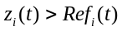 (26)
where Ref_{i}(t) is zero-crossing function of the i-th state variable.
Usually, zero crossing functions are considered as algebraic equations in (1) in the form (27):
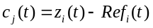 (27)
which sign change c_{j}(t_{d-})⋅c_{j}(t_{d+}) < 0 indicates t_{d} location. This condition can be checked at the final stage of the integration step. For zero-crossing functions, whose signs have been changed, t_{d} ∈ [t_{n-1},t_{n}] should be located with tolerance h_{min}. Since the integration scheme is based on the multistep integration method, a Nordsieck vector is available at t_{n} for all state variables (including algebraic ones) up to 2nd order:
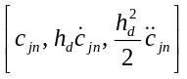 (28)
Using (28) one can solve equation (29) with respect to h_{d} :
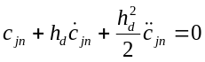 (29)
and calculate t_{d} = t_{n} – h_{d}. After the step with size h_{d}, the sign change check of (27) is repeated until at least one of the functions changes its sign. Practical simulations demonstrate the possibility of incorrect t_{d} location due to multiple changes of the sign of (27) at interval [t_{n-1}, t_{n}]. In this case, an additional zero-crossing function in the form 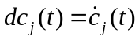, whose sign changes at the extrema of (27), significantly reduces the probability of missing t_{d}. This approach is proposed in [3] and it does not require to locate t_{d} for this condition. It is sufficient to detect a sign change of dc_{j}(t) and then use the bisection method to search for sign change of (27) in the interval [t_{n-1}, t_{n}].
Explicit use of zero-crossing functions is necessary in software implementations that use standard DAE solvers. In this case, these functions are part of an interface for representing events in the system being solved. In this paper, the custom solver is used, and therefore there is no need to consider zero-crossing functions explicitly by adding extra equations. Since there are Nordsieck vectors for variables (26), the solution of (27) can be obtained with the difference between the components of these vectors. Thus, the dimension of the system being solved does not change to represent the zero-crossing functions. In addition, about 80% of the constraints in the system (1) in practice have Ref_{j} = const, which further reduces the cost of t_{d} location due to the simplification of (27).
The separate class of discrete state events is time delays. A typical example is a relay that operates when a certain condition is met with delay ΔT_{R}. Processing models with a time delay requires the control of two related state events – the instants of pick-up and drop-out, if any. At the pick-up instant t_{d}, a new time event is generated for t_{d} + ΔT_{R}. If the relay drops in [t_{d}, t_{d} + ΔT_{R}], this event is canceled.
The interesting feature of the delayed relay events is that they can be used as a supplemental criterion to stop transient simulation before the designed duration time is reached. In many simulation scenarios, a transient is judged as stable when it has sufficient decay. In other words, the simulation continues until the "steady state" is reached. If there are delayed events on hold, they can significantly change the transient when applied to the model. Therefore, when the transient has sufficiently decayed, it is necessary to check for delayed events, and if there are none, the simulation can be safely finished. Neglecting of the events related to the protection of equipment can lead to an erroneous assessment of the stability [12]. Unstable transient detection is much easier in most cases. Besides numerical indicators of instabilities, some practical angle-based criteria can be used to detect loss of synchronous operation and abort simulation to save time.
Some types of state events may have more complex zero-crossing functions than (26). Such an event is, for example, the position of the out-of-sync relay protection complex impedance point within a designated area. The condition for such a state event cannot be represented by the single variable function. In addition, some constraints are defined in the form of piecewise functions, which requires the introduction of a state event in (1) solely for the purpose of switching to a new segment of the constraint due to derivative discontinuity. For such complex state events, a general location procedure has not yet been developed, and the location of t_{d} uses the bisection method.
The integration process described above is a classic DSAR solution. The contemporary approach to this problem is shifting towards a rigorous theory of solving systems of differential equations with a discontinuous righthand side [2]. There is positive experience of using this approach in the problem of transient simulation [13] with application to DAE. This research field is very promising for future work.

Software prototype implementation and simulation results
The software based on the approaches and algorithms described above is implemented in C++. It was designed to run on either Windows or Linux operating systems. The prototype called "Raiden" has a limited equipment model library, which includes only generic models necessary for basic simulations. However, the library can readily be extended with special tools for automatic model implementation [4]. The current library contents are listed in the Table I.
The initial conditions of the transient simulation are determined automatically with the embedded power flow solver, which implements the modified Newton method with initial guesses selection from Seidell or Continuous Newton methods [15], [16].
Raiden can use source data in a proprietary format based on JSON and can import data files in the format of the former transient simulator RUSTab and, to a limited extent, EUROSTAG formats. It is possible to save and load a "snapshots" of the state variables and service data of the model at an arbitrary simulation time t_{s}, which makes it possible to perform subsequent calculations on the same model from the time t_{s} without the need to re-integrate the interval [0;t_{s}). By default, during the simulation, all state variables’ time series are saved. To reduce the storage space required for results, the data compression method is used [17].
TABLE I. Equipment models description and features
Model | Description
Network | Network model in the form of YU=I.
Load | Active and reactive power frequency dependent load model in the form of piece-wise load response curve.
Generator | Infinite bus, simplified motion equation model, simplified model in the form of EMFs, full Park’s model with 2 or 3 damping windings and refinement of model parameters .
Excitation | Basic exciter model, AVR with PID and stabilization circuits, discrete excitation control.

Simulation results
Two test cases of different dimensions were used to compare the proposed software with the current implementation of the transient simulator RUSTab. The latter is relatively old software based on explicit methods, but it is known for its stability and simulation quality. The test cases descriptions are shown in Table II.
TABLE II. Test cases description and elements count
Model element | Case1 | Case 2
Buses | 887 | 7387
Branches | 1254 | 9279
Generators | 151 | 624
Loads | 730 | 6757
State variables | 8139 | 38244
A scenario with a duration of 150 s was simulated, including a three-phase short circuit with a duration of 0.1 s, followed by a line trip and its subsequent automatic reclosure. The transient almost completely decays at t > 45 s. Simulations were performed using RUSTab and the proposed software. For the RUSTab accuracy on differential variables was set to 10⁻⁵ (RUSTab do not check accuracy on algebraic variables). For the Raiden Rtol=Atol=10⁻⁴ were used. A comparison of simulation results of the most volatile state variable is shown in Fig. 3. In the Fig. 4 comparison of integration step sizes if shown. The Fig. 5 depicts a zoomed-in version of the RUSTab step size control results. The implicit method allows much larger step sizes when transient decays due to its superior numerical stability.
The times of simulations are shown in the Table III. It should be noted that the Raiden does not implement any parallel computing features, while RUSTab utilizes multithreading for vectorizing integration operations.
An additional simulation with a higher tolerance Atol=10⁻² was compared with the original simulation. The comparison of these results is shown in Fig. 6 and the step size comparison is shown in Fig. 7.

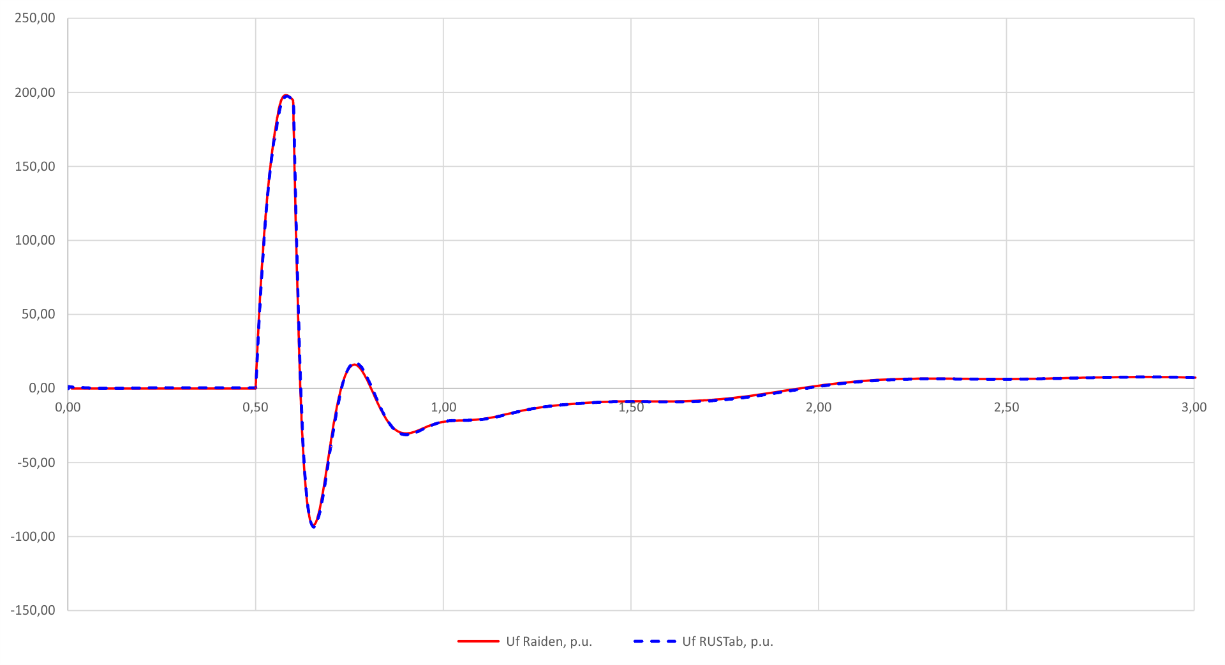
Fig. 3. Case 1 simulation results of AVR outputs
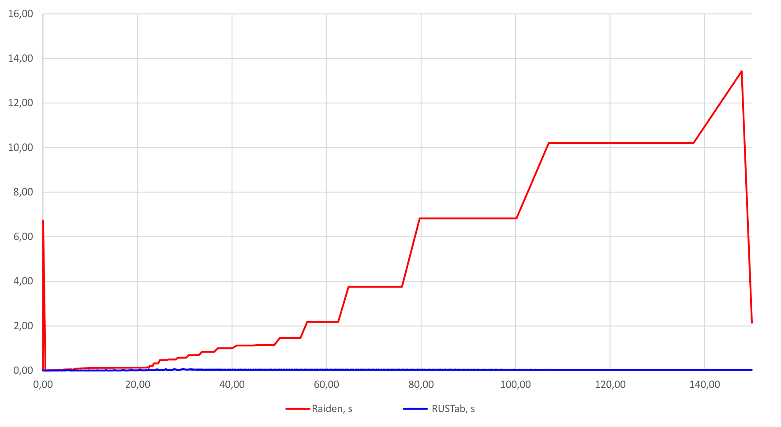
Fig. 4. Case 1 integration steps
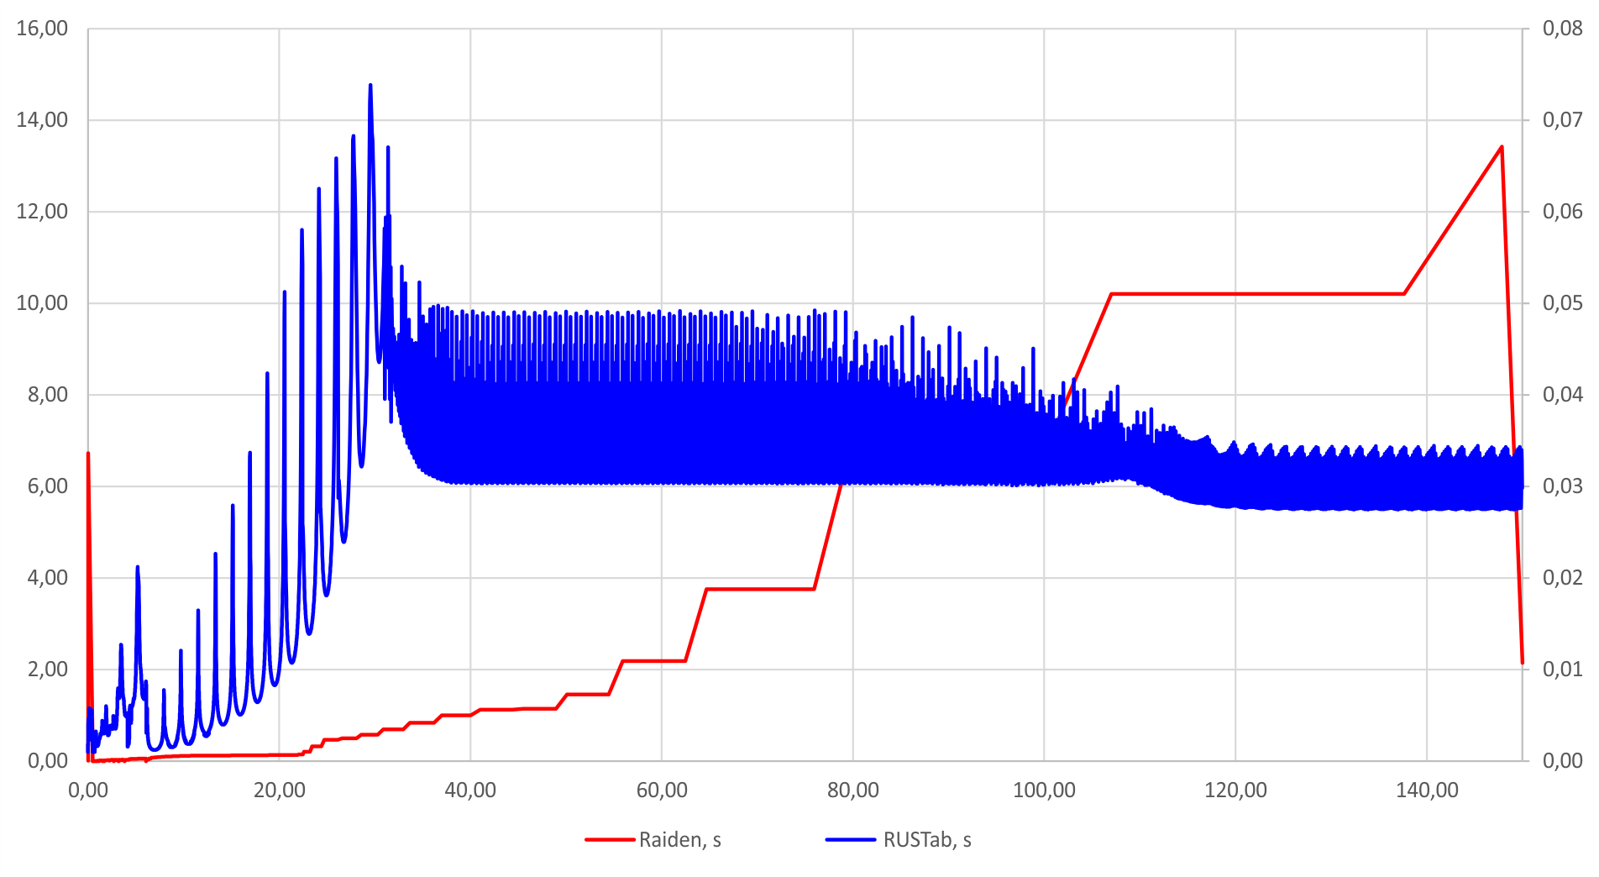
Fig. 5 Case 1 integration steps (zoomed)
TABLE III. Time of simulation and
step count for the case 1
 | RUSTab 10⁻⁵ | Raiden 10⁻⁴ | Raiden 10⁻²
Time, s | 77.9 | 4.9 | 3.7
Steps | 10628 | 2503 | 1842
The difference between simulation with Atol=10⁻² and simulation with Atol=10⁻⁴ is within given tolerance bounds while computation time decreased by 25%. Further increases of tolerance may lead to a reduction in simulation time and this effect can be used to perform rough estimations of stability. However, it should be noted that this can also lead to an inaccurate location of the state events and significant phase deviations when simulating long-term transients.
The second test case dimension is connected to a higher level of switchgear details included in the model. Such a models have become more common in recent years. About 30% of the branches of the network are breakers. The network dimension of this model is significantly reduced after topological processing. In this test case, the number of nodes for which equations were generated is 5141, which is approximately 70% of the original number of buses.

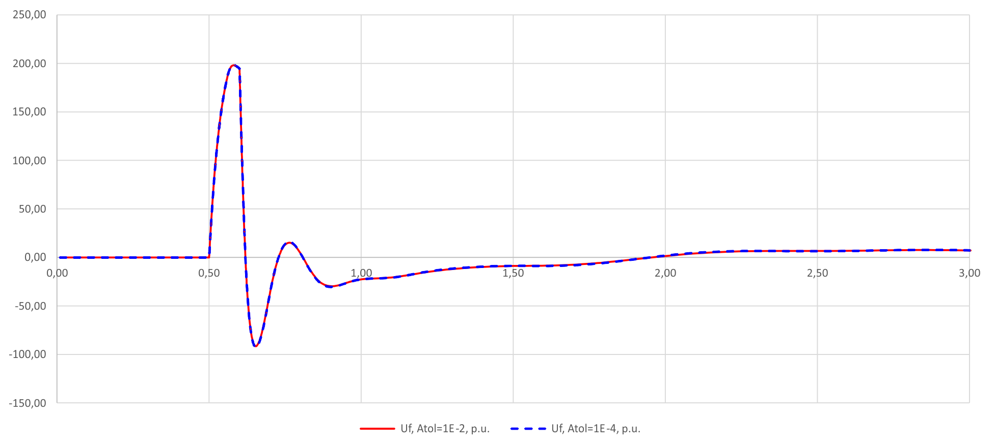
Fig. 6. Case 1 simulation results with different tolerances
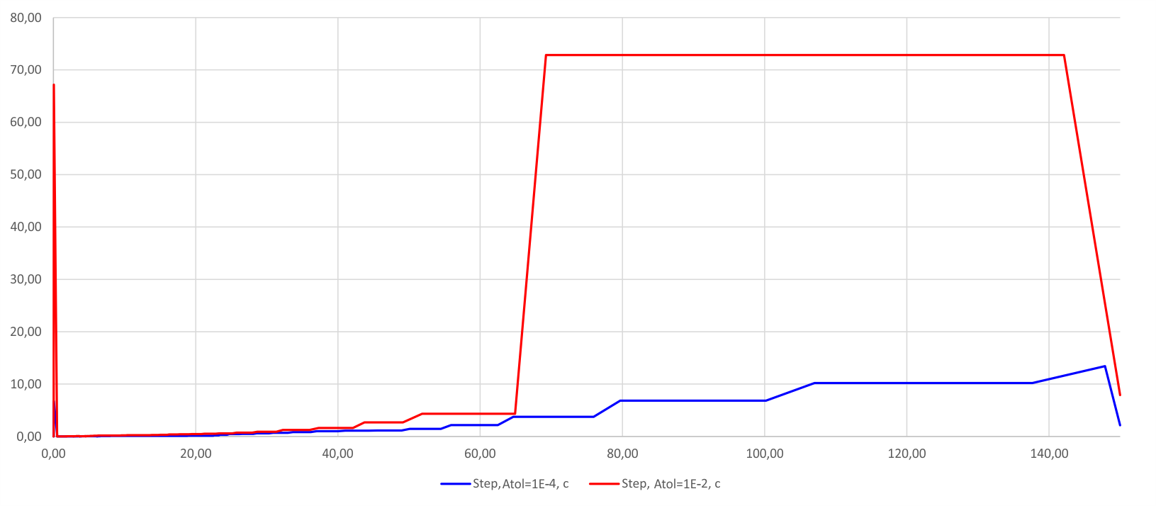
Fig. 7. Case 1 integration step with different tolerances
A scenario with a duration of 150 s was simulated, including a single-phase short circuit with a duration of 0.08 s, a line trip, and subsequent breaker failure with a delay of 0.255 s. The active phase of the transient decays at t > 15 s, but oscillations with small amplitudes persist until the end of the simulation. The comparison of simulation results is shown in Fig. 8.
Case 2 was subjected to another simulation with a higher tolerance Atol=10⁻². The comparison with the original simulation is shown in Fig. 9. There are slight differences between simulation results, caused, perhaps, by stronger BDF damping in the simulation with higher tolerance. When tolerance is increased, the integration scheme can increase step size, which reduces step number and simulation time in this case by 65%. The comparison of time used to simulate case 2 is shown in Table IV.
TABLE IV. Time of simulation and
step count for the case 2
 | RUSTab 10⁻⁵ | Raiden 10⁻⁴ | Raiden 10⁻²
Time, s | 4685.6 | 279.1 | 98.6
Steps | 79395 | 11293 | 3909

CONCLUSION
The developed prototype software convincingly shows the advantages of the implicit integration schemes for power system transient simulation. The higher complexity of the implementation of the algorithms is compensated with the help of automated development tools. Despite some unresolved issues, the considered scheme has prospects for application in online power system analysis tools that operate on a time scale close to real time. For power system models with high dimensions, the considered implementation of the algorithms makes it possible to obtain a significant advantage in the simulation time consumption in offline tasks.
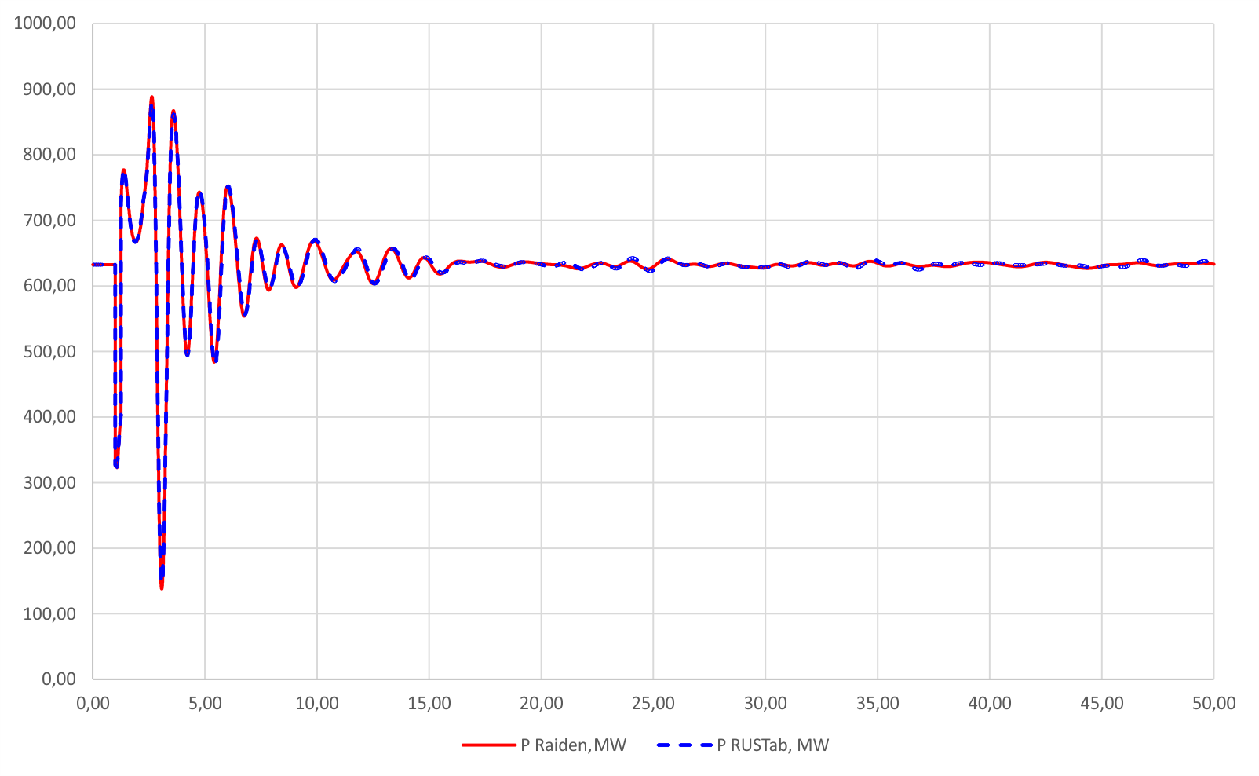Fig. 8. Case 2 simulation results of the generator output
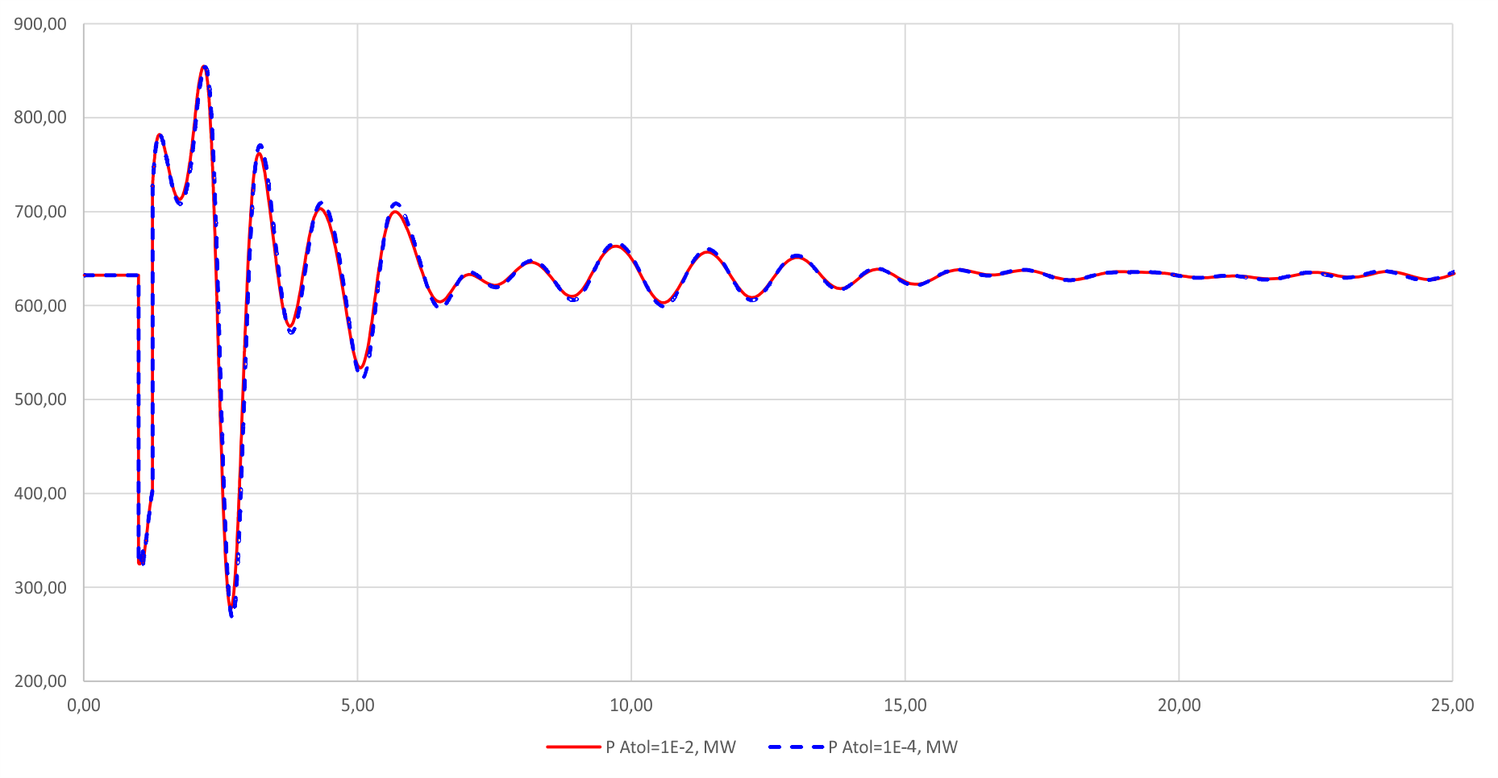
Fig. 9. Case 2 simulation results with different tolerances

References
- E. Hairer, S. P. Nørsett, and G. Wanner, Solving Ordinary Differential Equations I. Springer Berlin, Heidelberg, 1993.
- A. F. Filippov, Differential Equations with Discontinuous Righthand Sides, F. M. Arscott, Ed. Springer Netherlands, 1988. [Online]. Available: https://doi.org/10.1007/978-94-015-7793-9
- F. E. Cellier and E. Kofman, Continuous System Simulation. Springer, New York, 2006.
- E. Mashalov, “Automatic implementation of equipment models for transient stability simulation by symbolic manipulations,” Unpublished, 2022. [Online]. Available: https://rgdoi.net/10.13140/RG.2.2.29110. 78404
- C. Gear, “Simultaneous numerical solution of differential-algebraic equations,” IEEE Transactions on Circuit Theory, vol. 18, no. 1, pp. 89–95, 1971.
- J. Astic, A. Bihain, and M. Jerosolimski, “The mixed Adams-BDF variable step size algorithm to simulate transient and long term phenomena in power systems,” IEEE Transactions on Power Systems, vol. 9, no. 2, pp. 929–935, 1994.
- L.Petzold, “A Description of DASSL: A Differential/Algebraic System Solver, SAND82-8637,” Sandia Labs, Tech. Rep., 1982.
- “Deliverable d4.1 of the pegase. algorithmic requirements for simulation of large network extreme scenarios,” CRSA, RTE, TE, TU/e, Tech. Rep., 2011. [Online]. Available: http://fp7-pegase.com
- K. Radhakrishnan and A. C. Hindmarsh, “Description and use of LSODE, the livemore solver for ordinary differential equations,” Office of Scientific and Technical Information (OSTI), Tech. Rep., Dec. 1993. [Online]. Available: https://doi.org/10.2172/15013302
- J. A. Lee, J. Nam, and M. Pasquali, “A new stabilization of adaptive step trapezoid rule based on finite difference interrupts,” SIAM Journal on Scientific Computing, vol. 37, no. 2, pp. A725–A746, Jan. 2015. [Online]. Available: https://doi.org/10.1137/140966915
- I. Hiskens and P. Sokolowski, “Systematic modeling and symbolically assisted simulation of power systems,” IEEE Transactions on Power Systems, vol. 16, no. 2, pp. 229–234, 2001.
- T. V. Cutsem, M. Glavic, W. Rosehart, C. Canizares, M. Kanatas, L. Lima, F. Milano, L. Papangelis, R. A. Ramos, J. A. dos Santos, B. Tamimi, G. Taranto, and C. Vournas, “Test systems for voltage stability studies,” IEEE Transactions on Power Systems, vol. 35, no. 5, pp. 4078–4087, Sep. 2020. [Online]. Available: https://doi.org/10.1109/tpwrs.2020.2976834
- M. A. A. Murad, B. Hayes, and F. Milano, “Application of filippov theory to the IEEE standard 421.5-2016 anti-windup PI controller,” in 2019 IEEE Milan PowerTech. IEEE, Jun. 2019. [Online]. Available: https://doi.org/10.1109/ptc.2019.8810738
- I. Canay, “Modelling of alternating-current machines having multiple rotor circuits,” IEEE Transactions on Energy Conversion, vol. 8, no. 2, pp. 280–296, 1993.
- F. Milano, “Continuous newton’s method for power flow analysis,” IEEE Transactions on Power Systems, vol. 24, no. 1, pp. 50–57, 2009.
- J. A. L. F. J. MarcosTostado-V´eliz, Manuel A.Matos, “An improved version of the continuous newton’s method for efficiently solving the power-flow in ill-conditioned systems,” International Journal of Electrical Power and Energy Systems, vol. 124, p. 106389, Jan. 2021. [Online]. Available: https://doi.org/10.1016/j.ijepes.2020.106389
- E. Mashalov, “Power system transient stability simulation results compression method,” Unpublished, 2022. [Online]. Available: https: //rgdoi.net/10.13140/RG.2.2.10208.97289

